Kubernetes Crash Course: Learn the Basics and Build a Microservice Application

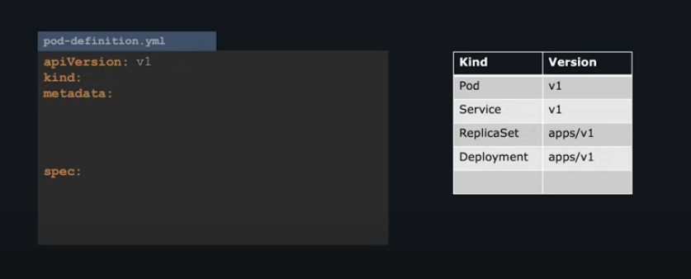

kind: values are case sensitive – and all the values are string type.

metadata: everything under metadata is dictionary – type.

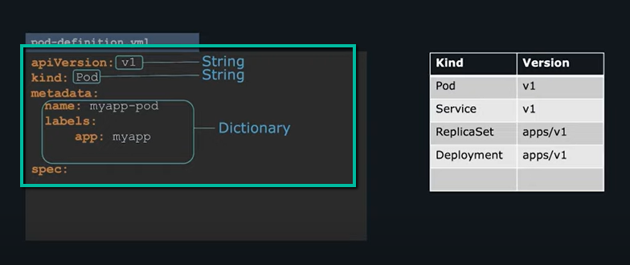

Under that

Spec: is a dictionary too, with 1st item in List

Both spec and metadata – are dictionary.

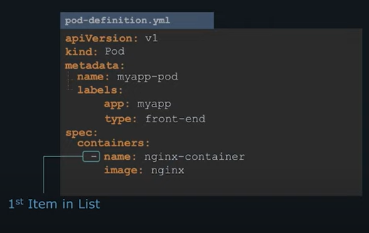

pod-definition.yml

*apiVersion: v1*

*kind: Pod*

*metadata:*

*name: myapp-pod*

*labels:*

*app: myapp*

*type: front-end*

*spec:*

*containers:*

*- name: nginx-container*

*image: nginx*

command to create this pod

kubectl create -f pod-definition.yml

**Replicaset**

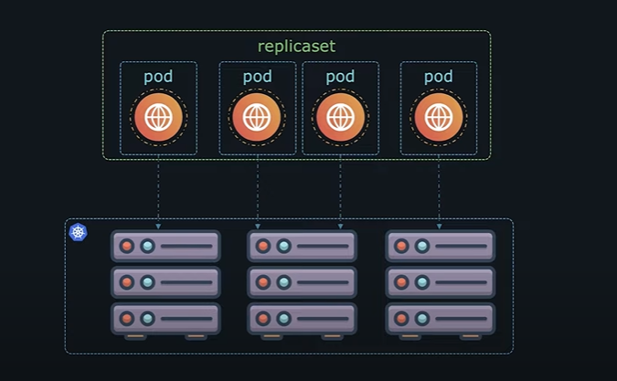

Writing the code for replicaset

apiVersion: apps/v1

kind: ReplicaSet

metadata:

name: myapp-replicaset

labels:

app: myapp

type: front-end

spec:

template:

|  |
| --- |
| **POD** |

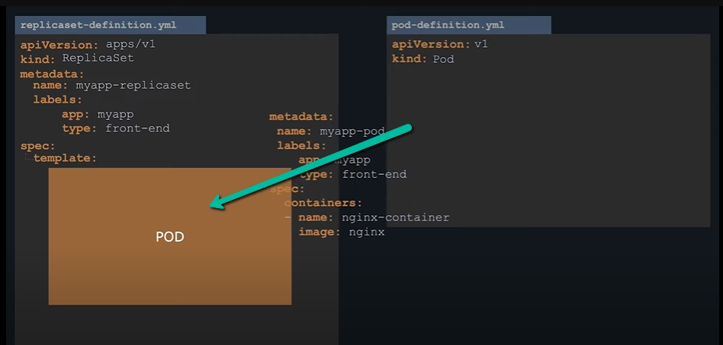

Under

Spec:

template:

move the existing pod metadata here

then add

replicas:

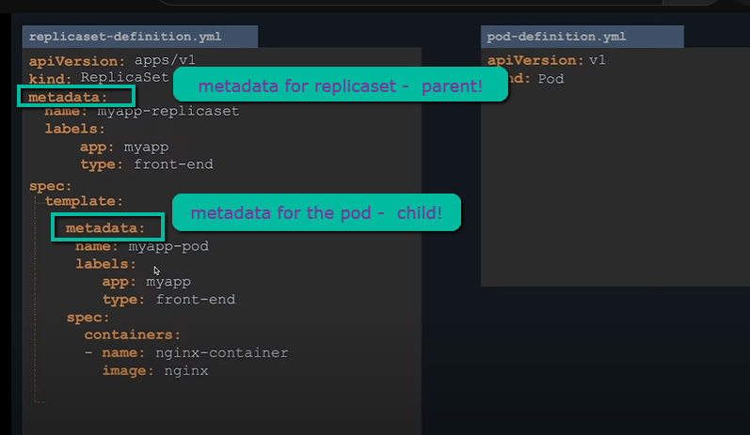

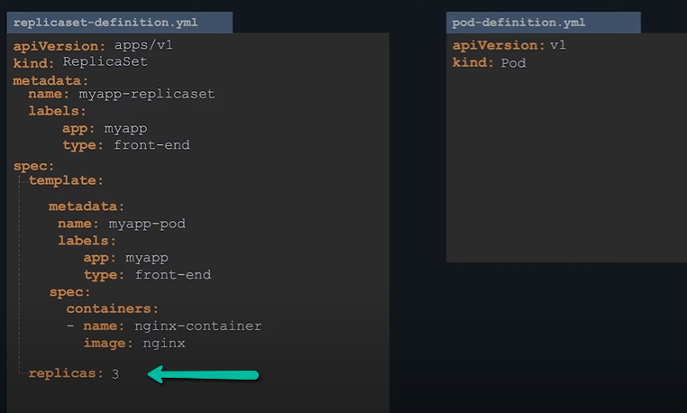

replicas and template are spec’s child

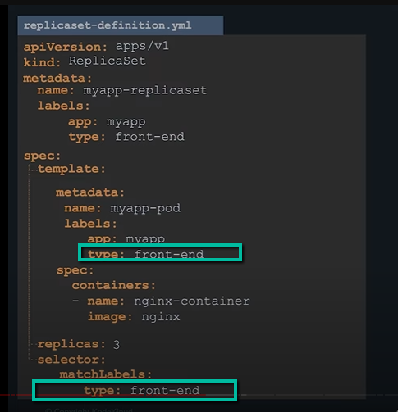

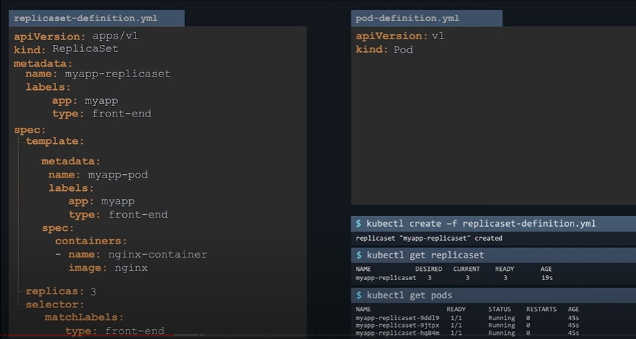

How to identify the pods – use the 🡪

selector :

matchLabels : tier: front-end

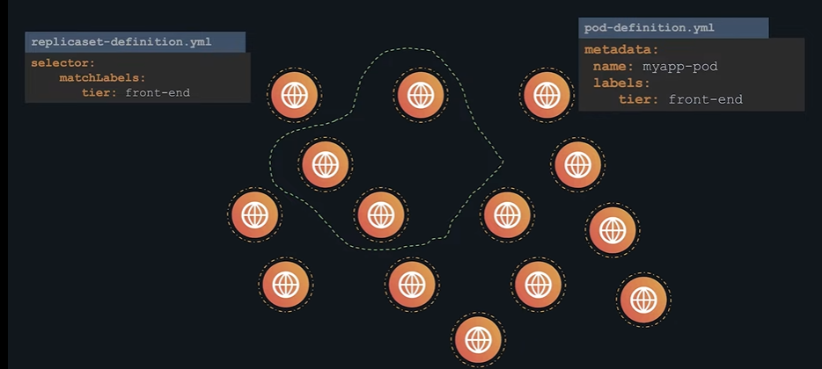

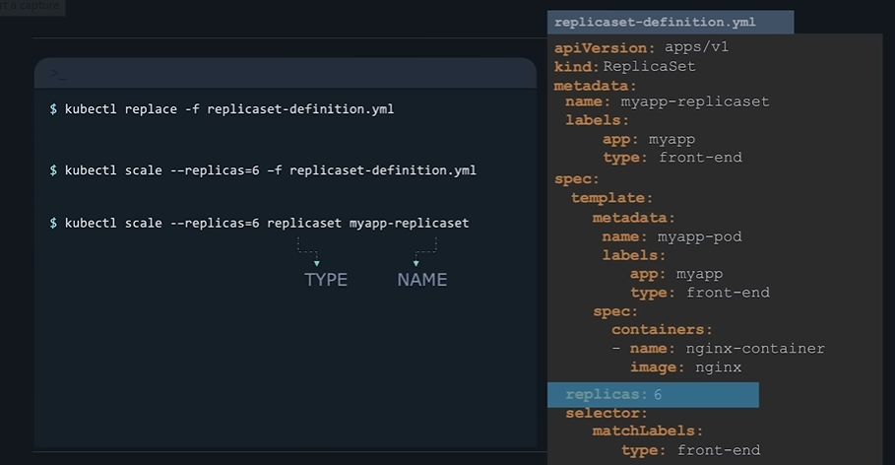

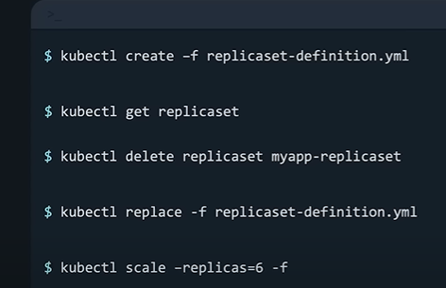

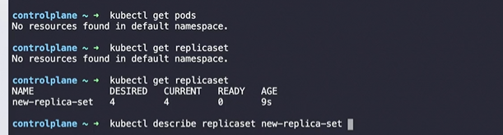

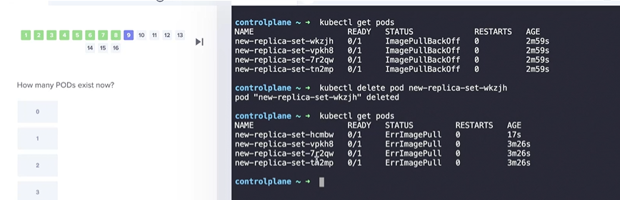

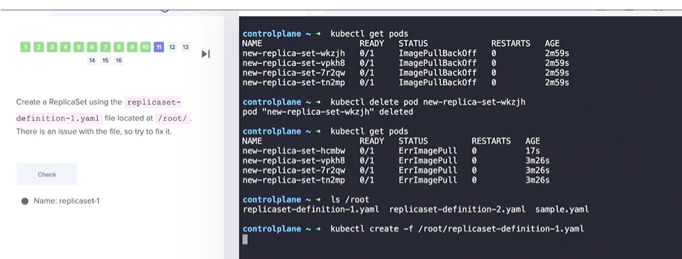

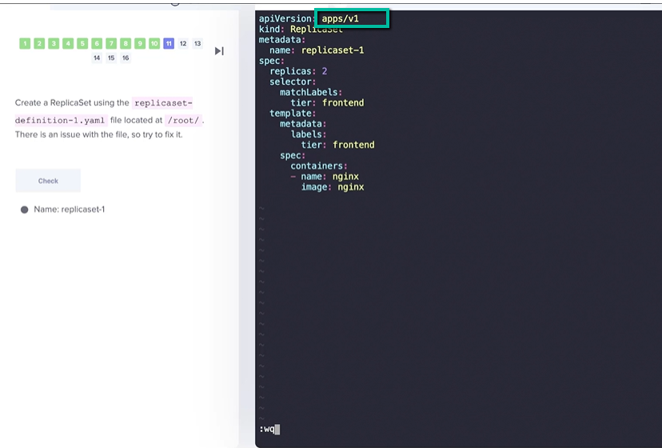

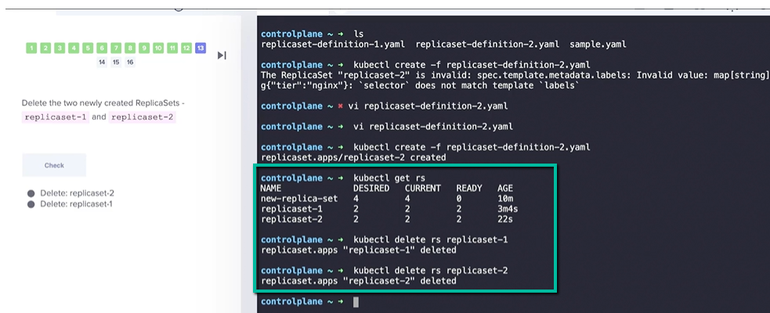



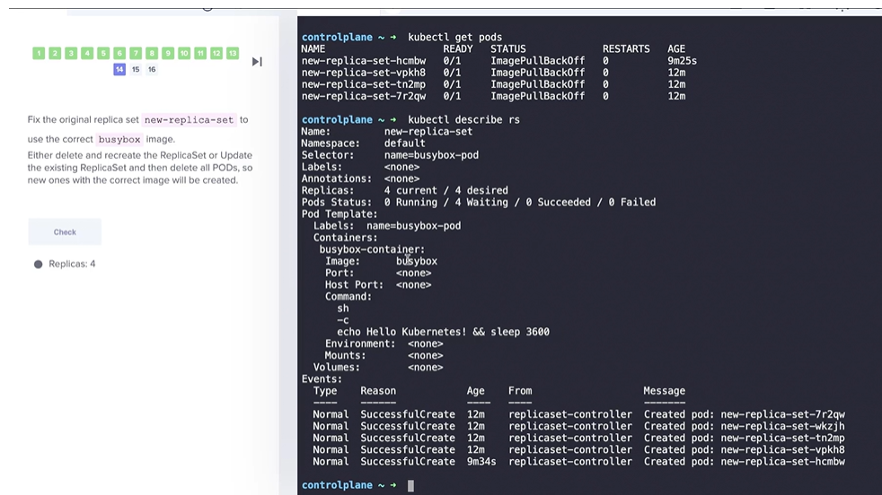

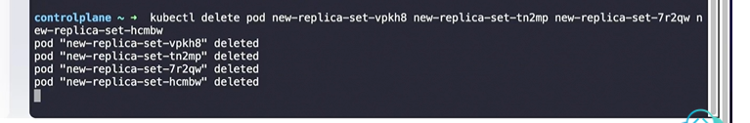

Kubectl edit rs new-replicaset

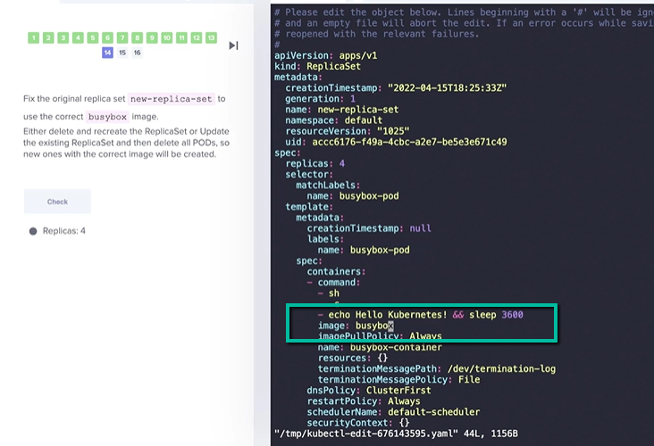

Delete the each pod manually and then replicaset gets new ones in.

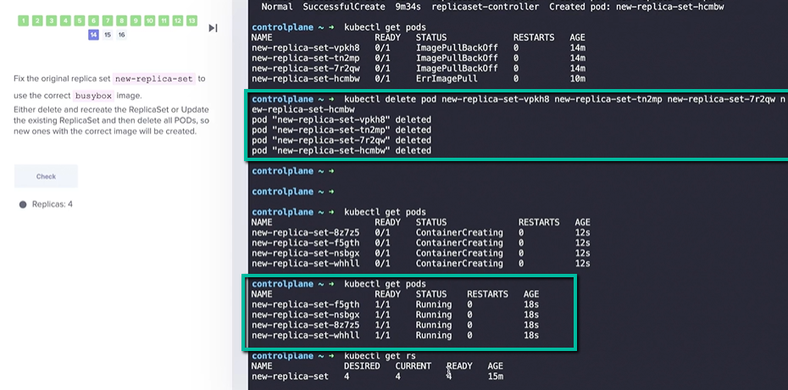

kubeclk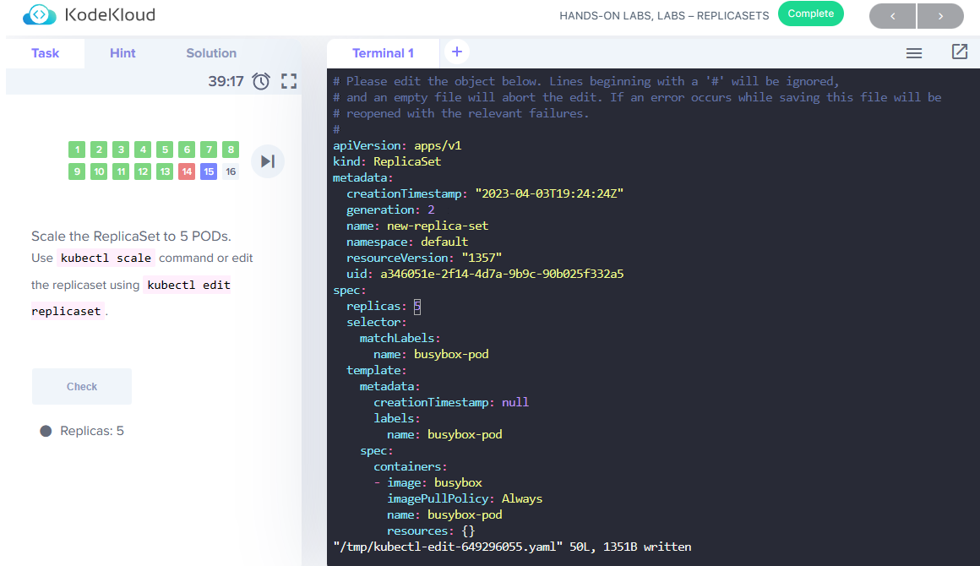

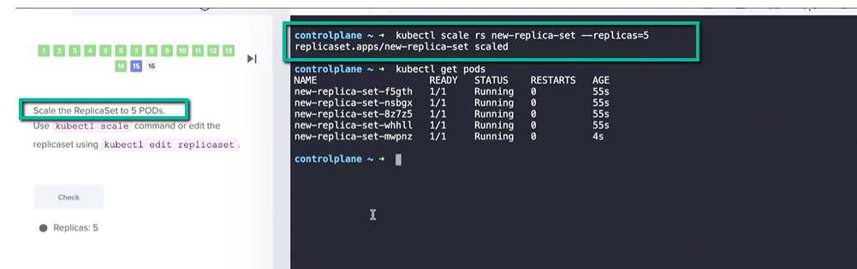

Reduce replicaset to 2

Kubeclt scale rs new-replica-set –replicas=2



===================Deployment===========================

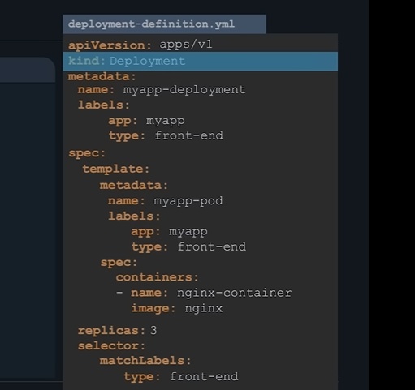

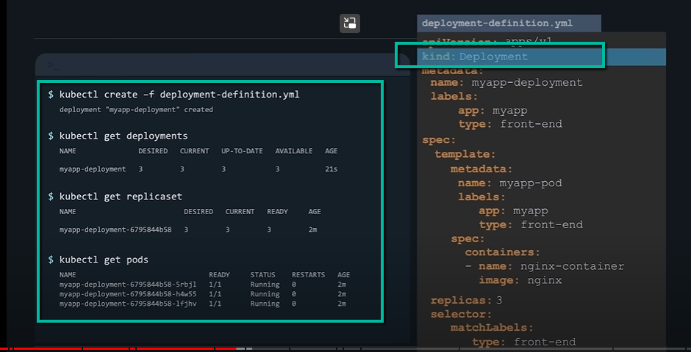

======================**Services**=======================================

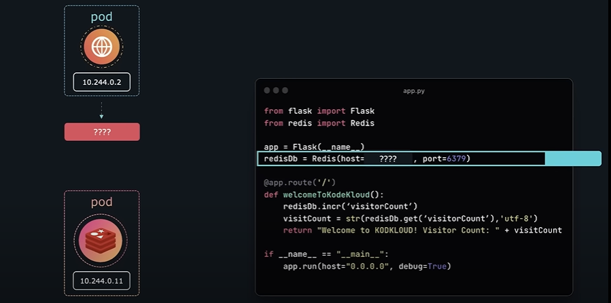

Why we need a service, because of ip address gets lost once pod are gone, every time a pod runs a new ip address is generated. This is why the service comes in

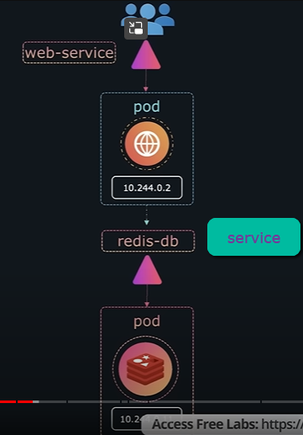

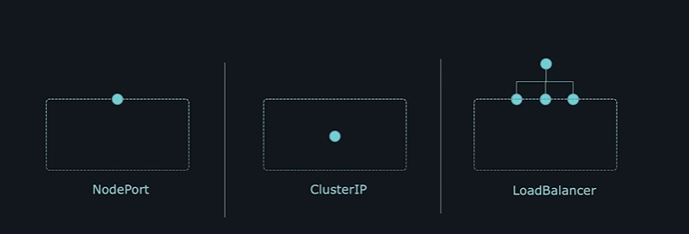

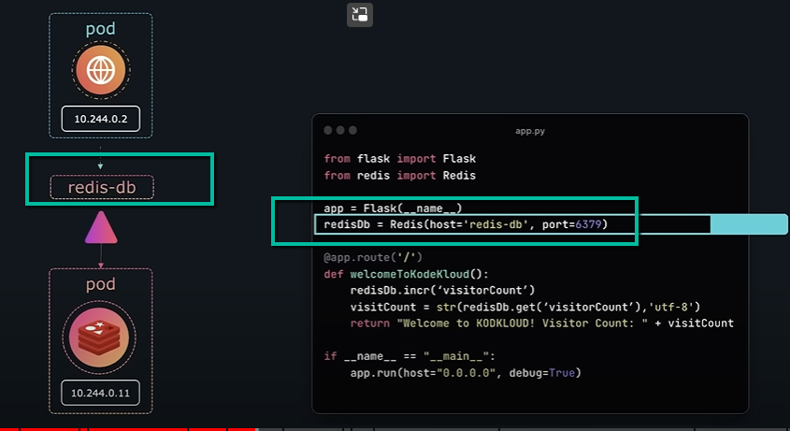

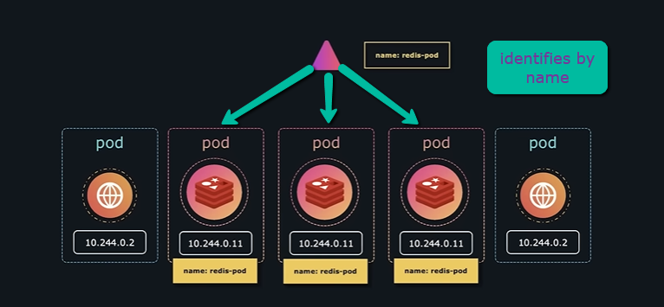

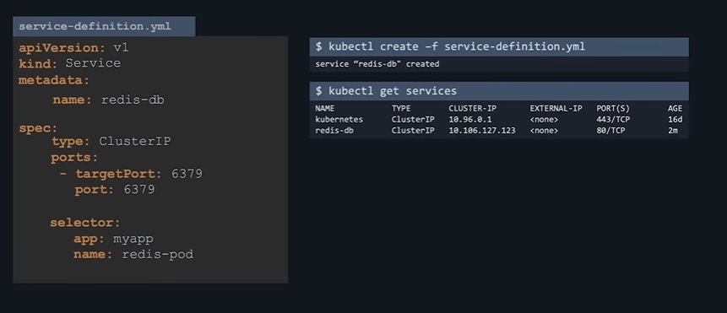

**Uses – label name to select the service.**

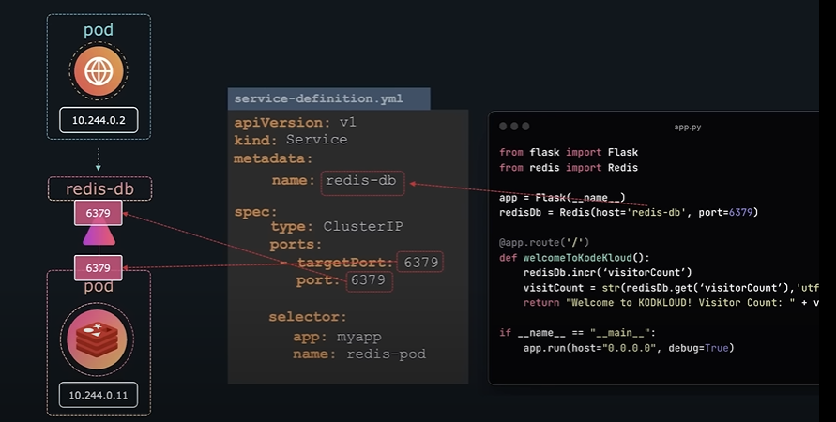

**Node port**

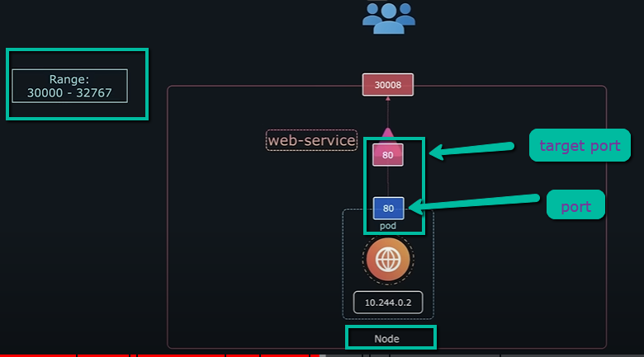

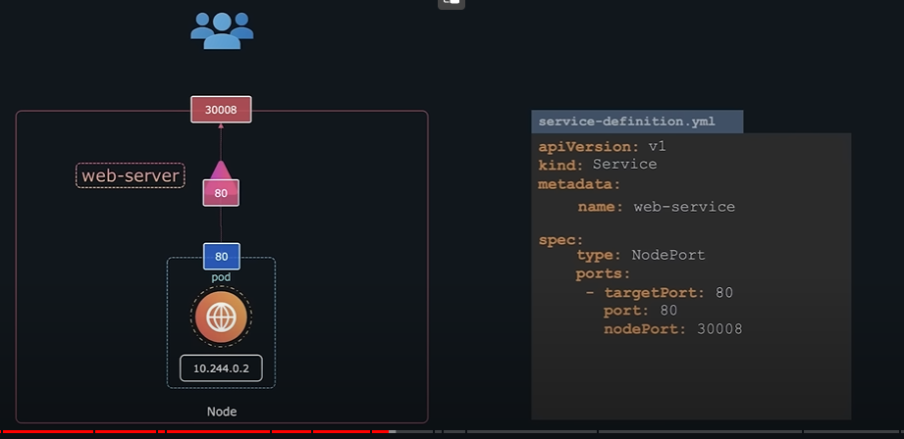

Only port: 80 is mandatory.

Others are not



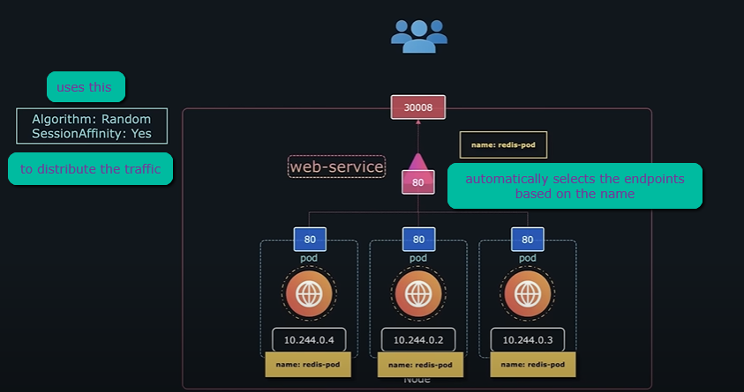

controlplane ~ ➜ kubectl create -f service-definition-1.yaml

service/webapp-service created

controlplane ~ ➜ kubectl get services

NAME TYPE CLUSTER-IP EXTERNAL-IP PORT(S) AGE

kubernetes ClusterIP 10.43.0.1 <none> 443/TCP 34m

webapp-service NodePort 10.43.148.37 <none> 8080:30080/TCP 33s

controlplane ~ ➜ kubectl describe service webapp-service

Name: webapp-service

Namespace: default

Labels: <none>

Annotations: <none>

Selector: name=simple-webapp

Type: NodePort

IP Family Policy: SingleStack

IP Families: IPv4

IP: 10.43.148.37

IPs: 10.43.148.37

Port: <unset> 8080/TCP

TargetPort: 8080/TCP

NodePort: <unset> 30080/TCP

Endpoints: 10.42.0.10:8080,10.42.0.11:8080,10.42.0.12:8080 + 1 more...

Session Affinity: None

External Traffic Policy: Cluster

Events: <none>

controlplane ~ ➜ curl http://10.42.0.10:8080

<!doctype html>

<title>Hello from Flask</title>

<body style="background: #e74c3c;"></body>

<div style="color: #e4e4e4;

text-align: center;

height: 90px;

vertical-align: middle;">

<h1>Hello from simple-webapp-deployment-c7c68b6f4-jxsfn!</h1>

</div>

controlplane ~ ➜

Using NodePort to create a service exposing endpoints

root@controlplane ~ ➜ cat vote-service.yaml

apiVersion: v1

kind: Service

metadata:

name: vote-service

spec:

type: NodePort

ports:

- targetPort: 80

port: 5000

nodePort: 31000

selector:

app: myapp

name: vote-service

root@controlplane ~ ➜

result of this

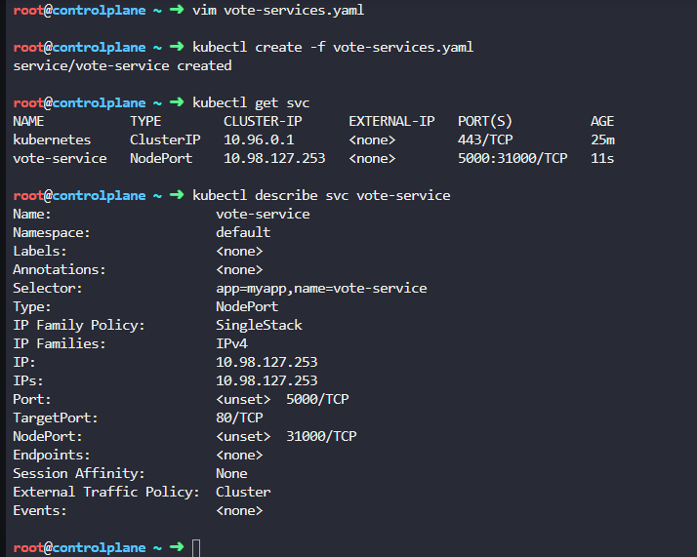

**How to implement this step by step :-**

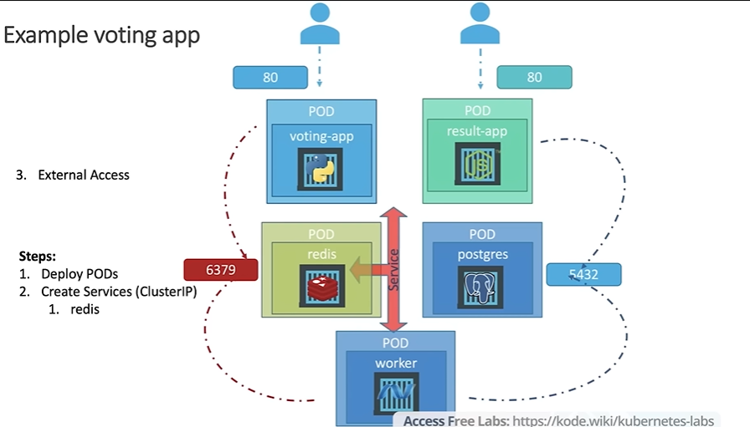

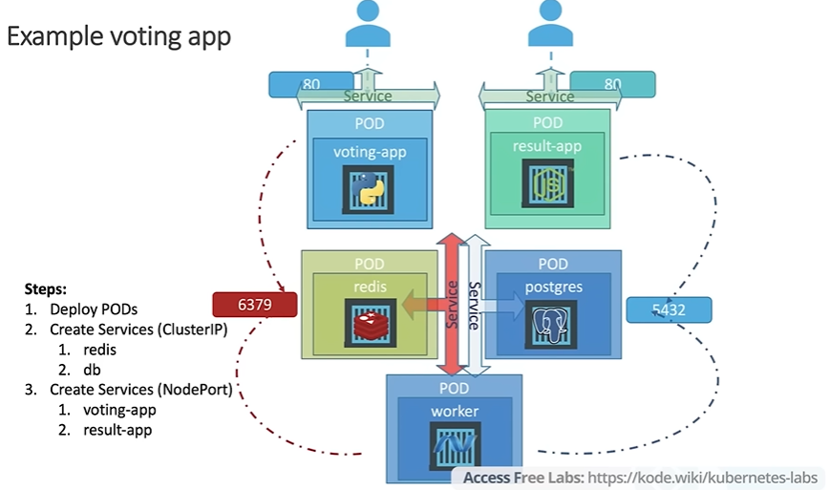

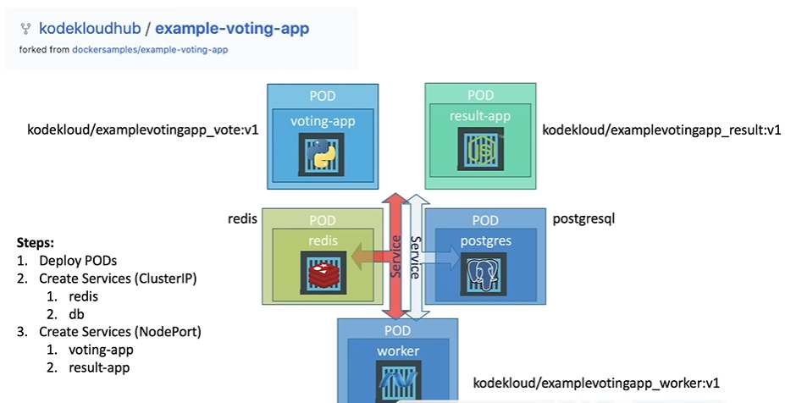

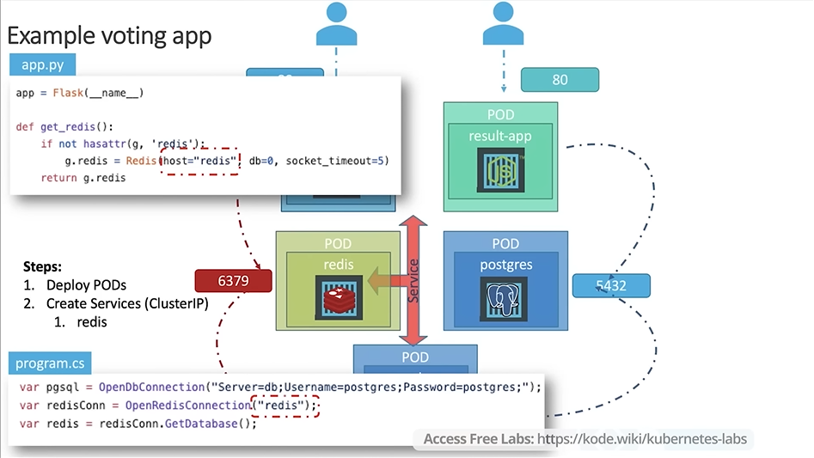

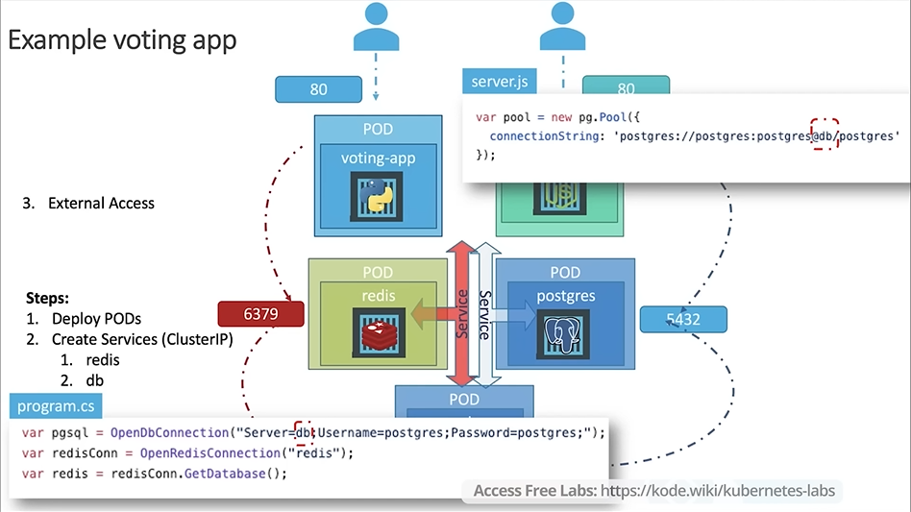



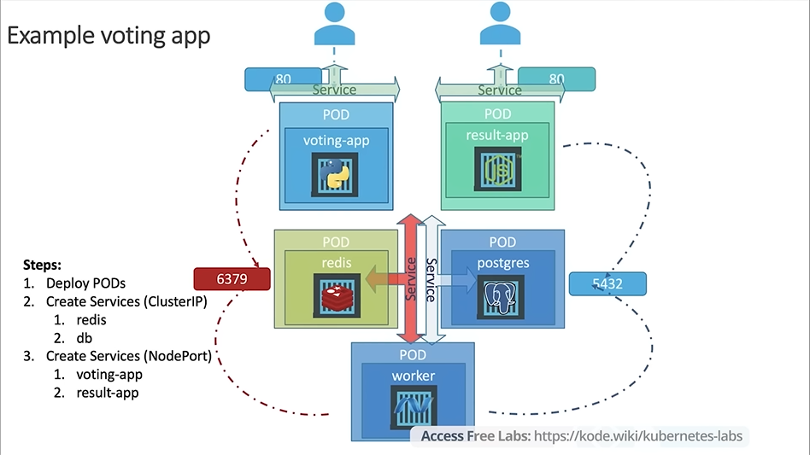

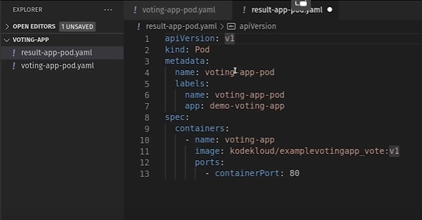

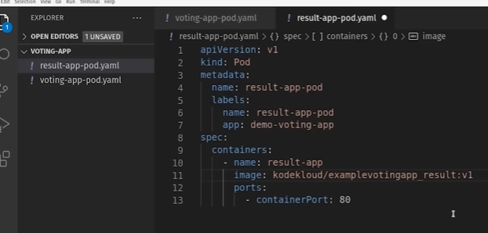

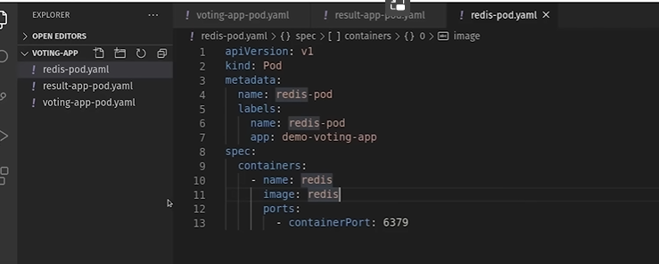

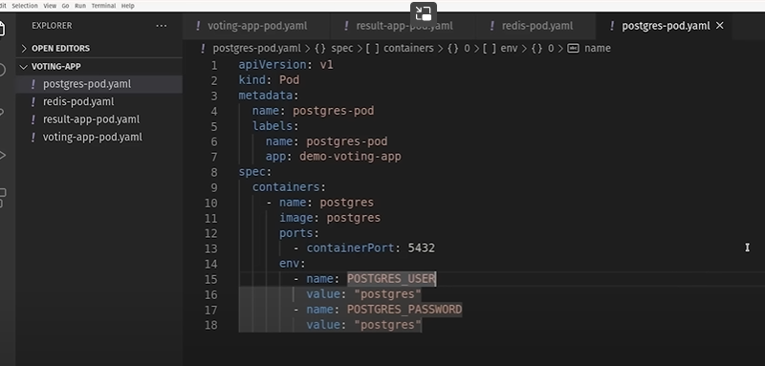

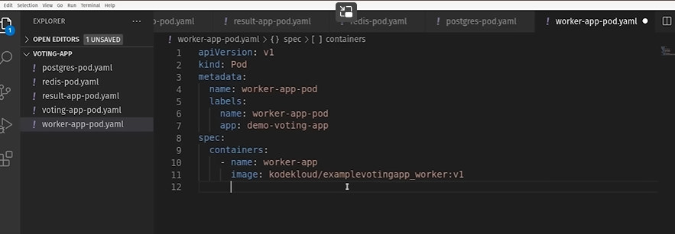

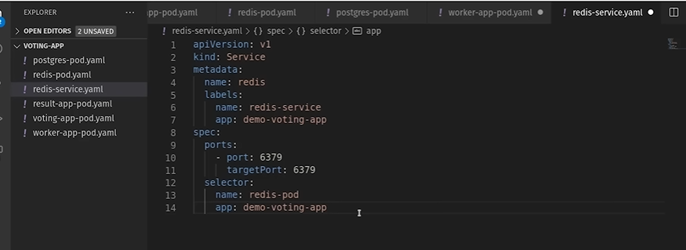

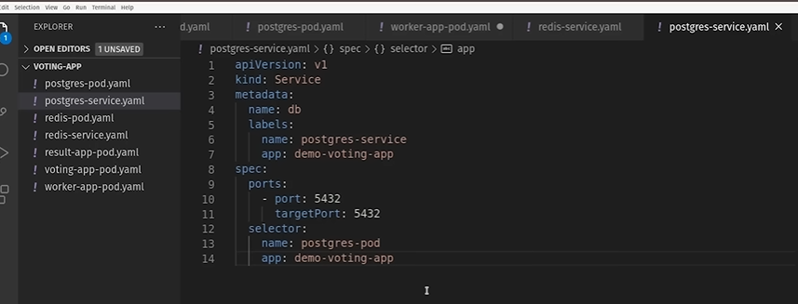



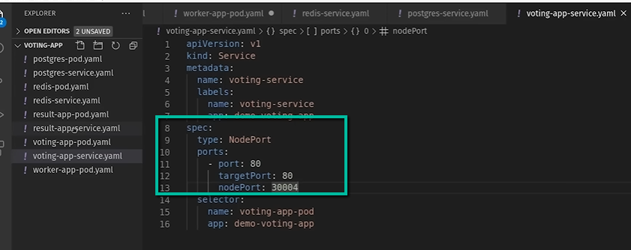

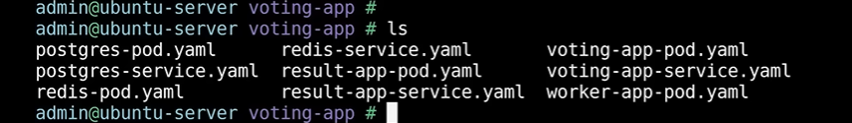

**After doing individual create pod and service**

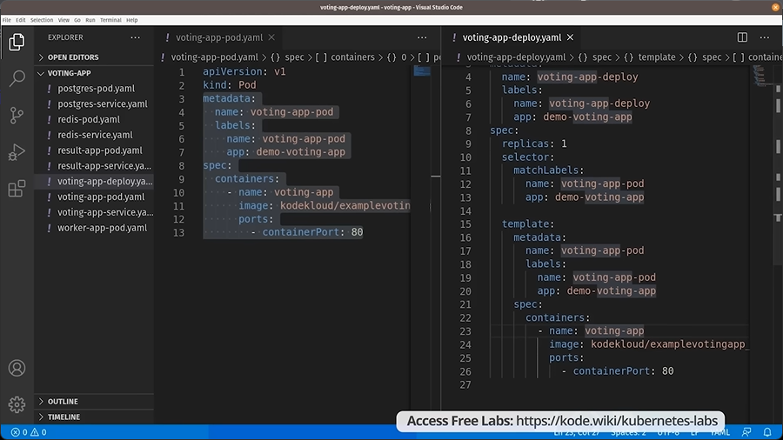

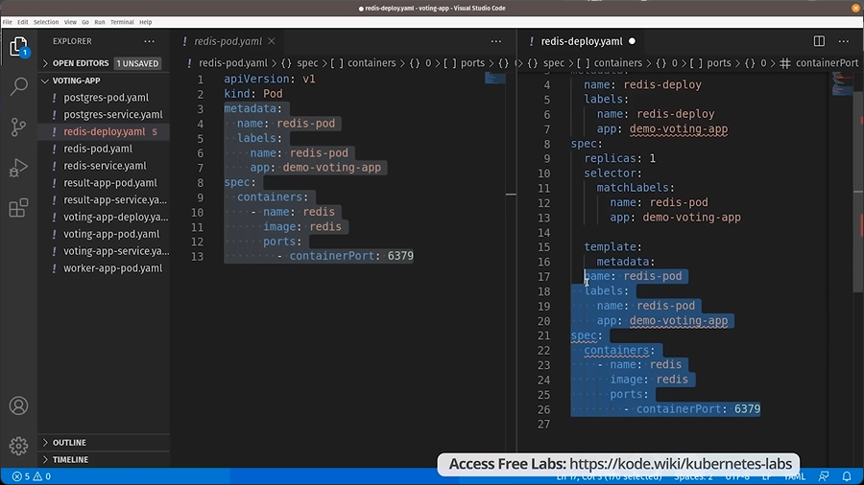

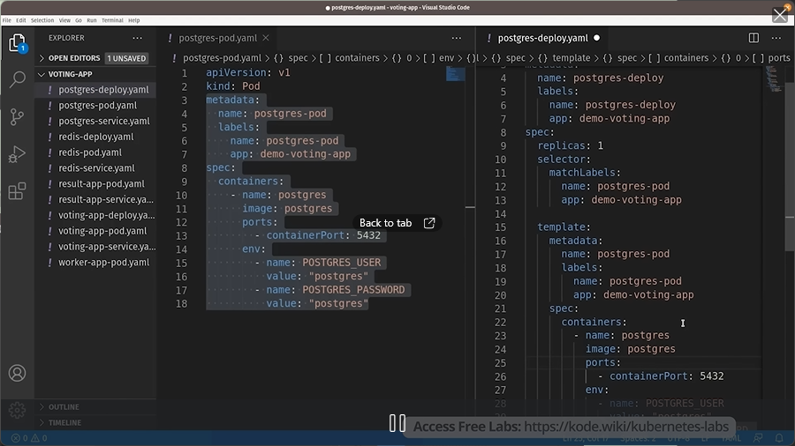

**Worker-app**

